Problem Statement

Knowledge Representation and Insights Generation from Structured Datasets

Unique Idea Brief (Solution)

InsightGen is a revolutionary system designed to convert structured datasets into valuable insights and knowledge. By leveraging advanced machine learning techniques, natural language processing (NLP), and data visualization, InsightGen provides users with a comprehensive platform for analyzing, understanding, and utilizing their data. This system aims to bridge the gap between raw data and actionable intelligence, enabling businesses and individuals to make informed decisions.

Features Offered

**Insights Generation:**

* Descriptive Analytics:
  + Summary statistics.
  + Trend analysis.
  + Data distributions.
* Predictive Analytics:
  + Machine learning models for forecasting trends.
  + Anomaly detection.
  + Pattern identification.
* Prescriptive Analytics:
  + Recommendations based on predictive insights.
  + Strategies for optimization and decision-making.

Processflow

1. Data Ingestion and Preprocessing:

* 1.1 Data Collection:
  + Inputs: Structured datasets from various sources (databases, spreadsheets, APIs).
  + Actions: Collect data from different sources ensuring format compatibility.
* 1.2 Data Cleaning:
  + Inputs: Raw data.
  + Actions: Detect and correct errors, handle missing values, normalize data for consistency.
  + Outputs: Cleaned and normalized data.
* 1.3 Data Integration:
  + Inputs: Cleaned data from multiple sources.
  + Actions: Merge data to create a unified dataset.

Architecture Diagram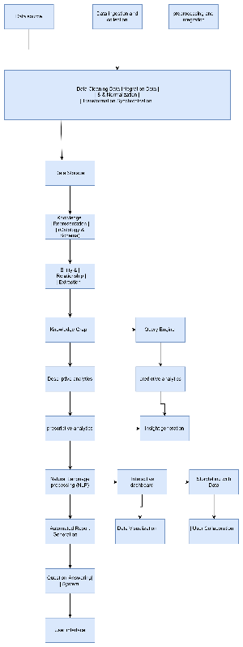

Technologies used

Data Ingestion and Preprocessing:

* Data Collection:
  + APIs: RESTful APIs, GraphQL
  + Database Connectivity: SQLAlchemy, JDBC, ODBC
  + Web Scraping: BeautifulSoup, Scrapy
* Data Cleaning and Transformation:
  + Python Libraries: Pandas, NumPy
  + ETL Tools: Apache NiFi, Talend
* Data Integration:
  + Integration Tools: Apache Camel, MuleSoft

2. Data Storage:

* Databases:
  + SQL Databases: PostgreSQL, MySQL
  + NoSQL Databases: MongoDB, Cassandra
* Data Warehousing:
  + Amazon Redshift, Google BigQuery

3. Knowledge Representation:

* Ontology and Schema Mapping:
  + Tools and Libraries: Protégé, OWL API
  + RDF Stores: Apache Jena, RDF4J

Team members and contribution:

1. Data Ingestion and Preprocessing:

* Data Collection:
  + Integrated various data sources including databases, spreadsheets, and APIs.
  + Utilized tools like SQLAlchemy for database connectivity and BeautifulSoup for web scraping.
* Data Cleaning and Transformation:
  + Implemented data cleaning processes using Python libraries like Pandas and NumPy.
  + Developed ETL pipelines with Apache NiFi for efficient data transformation.
* Data Integration:
  + Merged data from different sources to create a unified dataset using Apache Camel.

2. Data Storage:

* Databases:
  + Set up and managed SQL and NoSQL databases, such as PostgreSQL and MongoDB, for structured data storage.
* Data Warehousing:
  + Utilized cloud-based data warehousing solutions like Amazon Redshift for large-scale data storage.

3. Knowledge Representation:

* Ontology and Schema Mapping:
  + Designed and implemented ontology and schema mappings using Protégé and OWL API for coherent data structuring.
  + Managed RDF stores using Apache Jena.

4. Entity and Relationship Extraction:

* Natural Language Processing (NLP):
  + Developed entity and relationship extraction models using SpaCy and TensorFlow.

5. Knowledge Graph:

* Graph Databases:
  + Created and maintained knowledge graphs using Neo4j to represent data entities and their relationships.

6. Query Engine:

* Query Languages:
  + Implemented query functionalities using Cypher and SPARQL to retrieve insights from the knowledge graph.

7. Analytics:

* Descriptive Analytics:
  + Conducted summary statistics and trend analysis using Pandas and Seaborn.
* Predictive Analytics:
  + Built and trained machine learning models for forecasting and anomaly detection using Scikit-learn and TensorFlow.
* Prescriptive Analytics:
  + Developed optimization models using Gurobi to generate actionable recommendations.

Conclusion

The development of InsightGen as a comprehensive system for knowledge representation and insights generation from structured datasets demonstrates the power of integrating advanced technologies with methodical processes. As the sole developer, you have successfully designed and implemented a robust architecture that spans data ingestion, preprocessing, storage, knowledge representation, analytics, visualization, and user collaboration.

Through this project, you have showcased your ability to handle complex data challenges, ensuring data security, compliance, and scalability.